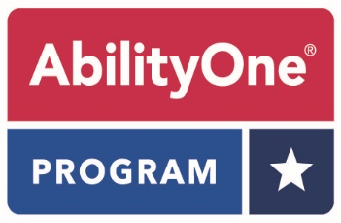

Essentially The Same (ETS)
Distributor Challenge Form

Date:

Distributor Name:

City/State:

This form is required to submit an ETS challenge. Please fill out all required fields and e-mail the completed form to Mike Jurkowski at mjurkowski@abilityone.gov. Please include “ETS Challenge” in the subject line. The average response time is ten (10) business days and will depend on the amount of research required. A sample of the commercial product will expedite the review process. Samples should be sent to:

James Frick-Tordella
National Industries for the Blind
3000 Potomac Avenue
Alexandria, VA 22305.

- Commercial Product Name: _______________________________________

- Commercial Product SKU/Item Number: _____________________________

- Name of catalog where the product appears: _________________________

- Catalog Page Number: ____________________________________________

- AbilityOne NSN: _________________________________________________
Essentially The Same (ETS)
Distributor Challenge Form
Page 2

Please provide a detailed description of your challenge (price is not a valid challenge):

Submitted by:

Name: _________________________________________________________________________________

Signature: _____________________________________________________________________________

Title: ___________________________________________________________________________________

Date: ___________________________________________________________________________________

Phone: _________________________________________________________________________________

E-Mail: _________________________________________________________________________________

